Leicester City Council

Domestic footway crossing application form
(only for properties within Leicester City boundary.)

Applicant details
Title and full name
Address
Make and model of current
vehicle(s) and registration numbers
Daytime telephone number
Are you the property owner? | Yes / No*

*Please note that if you do not own the property, written permission from the property owner needs to be submitted with this application form. Council tenants should contact their local area housing office.

Crossing details
Address crossing is to be
constructed
(if different from above)
Position of the crossing | □ Front of property
(Tick as appropriate) | □ Rear of property
 | □ Side of property

Type of Crossing

□ Single □ Double* □ Extension to existing crossing

(Serves 1 Property) (Serves 2 properties)

*Double crossings note: written permission will be required from your neighbour before a crossing can be constructed at their address, and should be supplied with this application form.

For double crossings please state adjoining property number ____________

I wish to apply for a domestic footway crossing.

Date: Signature of Applicant:

Please return to:

Engineering & Contracts Team 90 Leycroft Road

Leicester LE4 1BZ

Proposed site layout

Please draw a detailed sketch showing the layout and position of the proposed access, providing width and length measurements. Show any items of street furniture that may be an obstruction on the sketch. (See diagram below)
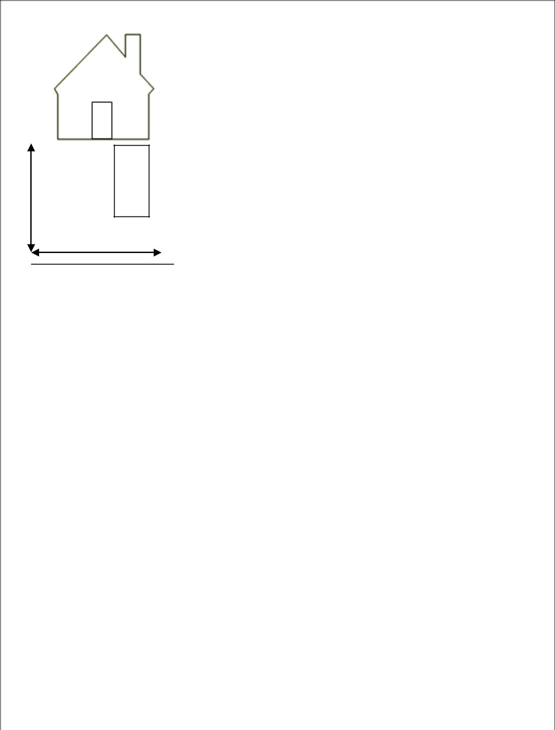

C
A
R
Length

Width

Footway

